**Infosys Springboard Internship**

**Object Recognition System**

**By Rohan Arora**

**Sri Harshitha N V N S**

**Meghana Duguru**

**Harshini**

**Ashutosh Dubey**

**INDEX**

1. **Acknowledgement**
2. **Abstract**
3. **Introduction**
4. **Methodology**
5. **Comparative Analysis**
6. **Results and Conclusion**
7. **References**

**Acknowledgement**

I, Rohan Arora, would like to extend my heartfelt gratitude to Infosys Springboard for providing me with the invaluable opportunity to undertake the internship project titled "Object Recognition System of Infosys Springboard." I am truly grateful to the entire team for their support and for making this experience so enriching.  
  
I would like to express my sincere appreciation to my mentor, Mr. Anil Shaw, whose continuous guidance and expertise helped me navigate through the complexities of the project. Their insightful feedback and constant encouragement played a crucial role in shaping the success of this project.  
  
A special thanks to my peers and colleagues, whose collaborative spirit and teamwork were instrumental in the progress and completion of this project. Their diverse perspectives and unwavering support made a significant impact on the overall learning experience.  
  
Additionally, I am deeply grateful to my family and friends for their unwavering support and motivation throughout this endeavor. Their encouragement, both personally and professionally, has been a constant source of strength, and I owe much of my success to their belief in me.  
  
Lastly, I would like to acknowledge everyone who has been a part of this journey, directly or indirectly. Their contributions have been invaluable in helping me achieve the objectives of this project and in fostering my academic and professional growth.  
  
Thank you all for your support and encouragement.

**Abstract**

Object recognition systems have revolutionized various domains, from autonomous vehicles to medical imaging. Their ability to identify, detect, and classify objects in real-time has significantly improved the functionality and efficiency of systems in these fields. This report provides a detailed account of the development and implementation of an object recognition system undertaken as part of the Infosys Springboard internship project.   
  
The project followed a step-by-step methodology, beginning with an in-depth analysis of the dataset through data visualization techniques. This was followed by edge detection methods, such as the edge detector, and heatmap analysis to better understand the distribution and features within the data. These preliminary steps ensured that the system was working with clean, relevant, and informative data for the object recognition task.  
  
To detect and segment objects effectively, we employed two state-of-the-art algorithms: Faster R-CNN and Mask R-CNN. Faster R-CNN, with its region proposal network (RPN), efficiently predicted object bounding boxes, while Mask R-CNN extended the capabilities to pixel-wise segmentation. These models demonstrated strong performance in recognizing and distinguishing objects across various scenarios.  
  
Finally, for real-time and high-speed object detection, we integrated the YOLOv5 and YOLOv5x models. YOLOv5 is known for its impressive accuracy and speed in detecting objects in real-time, making it an ideal choice for applications requiring low-latency detection. YOLOv5x, with its increased complexity, further improved detection accuracy at the cost of some speed, providing an excellent balance between performance and processing time.  
  
This report provides a comprehensive overview of the object recognition system’s development, discussing the advantages, disadvantages, and compatibility requirements of each employed methodology. The comparative analysis helps in understanding the trade-offs between detection accuracy, speed, and computational complexity, providing valuable insights for selecting the most suitable approach for specific use cases.

**Introduction**

Object recognition systems have made significant strides in transforming various industries, including autonomous driving, healthcare, and security, by enabling machines to identify and interact with objects in real-time. This report outlines the comprehensive development and implementation of an object recognition system as part of the Infosys Springboard internship program. The project was designed to explore and apply state-of-the-art techniques in computer vision to build a robust, real-time object detection and segmentation system.

The project followed a systematic and iterative methodology. The initial phase focused on **data visualization** to understand the structure and features of the dataset. This was followed by **edge detection** techniques to highlight important object boundaries and improve feature extraction. **Heatmap analysis** was employed to identify patterns and correlations within the data, aiding in the refinement of the model’s accuracy.

For the object detection and segmentation tasks, we integrated powerful models such as **Faster R-CNN** and **Mask R-CNN**. Faster R-CNN provided a high level of accuracy for object detection by utilizing region proposal networks (RPN) for efficient object localization. Mask R-CNN extended Faster R-CNN by adding segmentation capabilities, allowing for pixel-wise object classification, which is crucial in applications like medical imaging and robotics.

To address the challenges of speed and real-time performance, we incorporated **YOLOv5** and its variant **YOLOv5x**. These models are renowned for their speed and efficiency in object detection, enabling real-time detection with minimal latency. The YOLO models were optimized to run efficiently while maintaining high detection accuracy, making them suitable for applications where real-time processing is critical, such as in autonomous vehicles and security surveillance systems.

This report provides a detailed analysis of the methodologies used, outlining their respective advantages and disadvantages. It also discusses the compatibility and performance requirements of each model, along with their integration into the final object recognition system. Additionally, we address the challenges encountered during the development process, the solutions implemented, and the outcomes achieved. Through this comprehensive approach, we demonstrate how the combination of various cutting-edge models can create an object recognition system that balances accuracy, speed, and practicality.

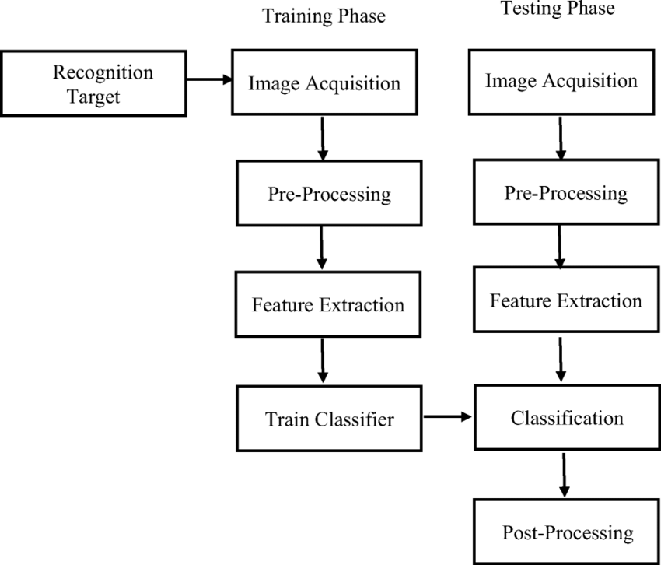

**Methodology**

1. **Data Exploration, Visualization, and Preprocessing**

To ensure the project’s success, we began with a thorough analysis of the COCO dataset, a widely-used benchmark dataset for object detection. This phase included:

* **Exploratory Data Analysis (EDA):**
  + Evaluated class distributions to identify any imbalances.
  + Checked for missing or incomplete annotations.
  + Visualized image resolutions to standardize preprocessing steps.
* **Heatmap Generation:**
  + Generated heatmaps to visualize the density and spatial distribution of objects within the images.
  + Identified common object locations, which informed model training strategies.
* **Edge Detection:**
  + Utilized edge detection algorithms (e.g., Canny Edge Detection) to enhance object boundaries.
  + This step was particularly useful for detecting smaller or overlapping objects.
* **Data Cleaning and Augmentation:**
  + Addressed dataset inconsistencies by removing duplicate or mislabelled annotations.
  + Applied augmentations such as rotation, scaling, and color jittering to diversify training data.
* **Advantages:**
  + Improved understanding of dataset characteristics.
  + Enhanced model performance through better-prepared data.
* **Disadvantages:**
  + Computationally expensive for large-scale datasets.
* **Compatibility Requirements:**
  + Python libraries: Matplotlib, Seaborn, OpenCV, and NumPy.
  + Hardware: High-memory systems for handling large datasets.

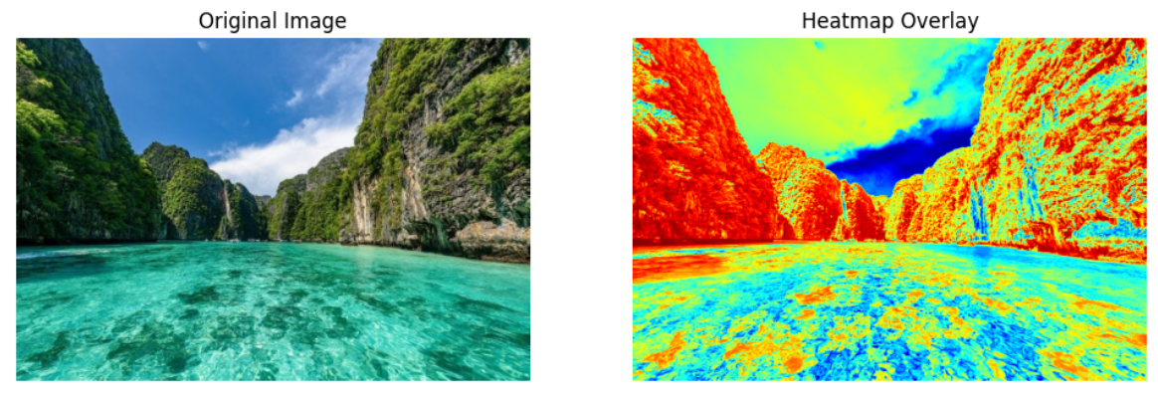

1. **Faster R-CNN (Region-Based Convolutional Neural Networks)**

Faster R-CNN is a highly influential and widely used deep learning model for object detection tasks. Building upon the earlier R-CNN and Fast R-CNN architectures, Faster R-CNN introduces the concept of **Region Proposal Networks (RPNs)**, which significantly improves the speed and efficiency of the object detection process. This innovation allows the model to simultaneously propose candidate regions and classify objects, streamlining the entire object detection pipeline.

**Architecture:**

The architecture of Faster R-CNN can be broken down into two key components:

1. **Feature Extraction via Convolutional Neural Networks (CNNs):**  
   At its core, Faster R-CNN leverages a convolutional neural network (CNN) for feature extraction. The CNN can be based on various backbone networks, such as **ResNet**, **VGG16**, or **Inception**, to extract hierarchical features from input images. These features serve as the foundation for detecting objects in the image.
2. **Region Proposal Network (RPN):**  
   The Region Proposal Network is a crucial addition in Faster R-CNN that distinguishes it from its predecessors. The RPN is responsible for generating region proposals—rectangular areas of the image that are likely to contain objects. It works by sliding a small network over the convolutional feature map produced by the CNN. The RPN outputs a set of potential bounding boxes and their associated objectness scores, which indicate the likelihood that each proposed region contains an object.
3. **Object Classification and Bounding Box Refinement:**  
   After the RPN generates region proposals, a second network (often a fully connected network) is used to classify the objects within these proposals. Additionally, bounding box regression is performed to fine-tune the location of the detected object, ensuring higher localization accuracy. The output is a set of classified objects along with refined bounding boxes.
4. **End-to-End Learning:**  
   One of the major advantages of Faster R-CNN is its ability to perform **end-to-end training**. This means that the entire model, including both the feature extractor and the RPN, can be trained together in a single optimization process. This approach eliminates the need for separate training stages, as was the case with earlier object detection models like R-CNN.

**Steps Taken in Implementing Faster R-CNN:**

**Dataset Preprocessing:**

The first step in implementing Faster R-CNN was preprocessing the dataset to ensure it was in a compatible format for the model. This involved annotation of images to include ground truth bounding boxes and object labels. The dataset was divided into training, validation, and testing sets to evaluate the model's performance. Each image was resized and normalized to fit the input requirements of the chosen CNN backbone (e.g., ResNet).

**Model Training:**

The model was trained using the prepared annotated dataset. The training process involved optimizing the model to minimize both the classification loss (error in predicting the object class) and the localization loss (error in predicting the bounding box coordinates). This was achieved through backpropagation and stochastic gradient descent (SGD). Special attention was paid to ensuring that the dataset had a balanced representation of different object classes to prevent class imbalances that could affect model performance.

**Advantages of Faster R-CNN:**

1. **High Accuracy:**  
   Faster R-CNN provides state-of-the-art accuracy in object detection tasks, particularly in environments with complex scenes containing multiple objects. By incorporating the RPN, it can generate highly accurate region proposals, leading to better detection results.
2. **Robustness to Complex Scenes:**  
   Faster R-CNN is capable of handling images with multiple objects and cluttered backgrounds. The RPN improves its robustness by effectively filtering out regions that are unlikely to contain objects, enabling the model to focus on the most promising areas of the image.
3. **End-to-End Training:**  
   The ability to train the model end-to-end simplifies the training pipeline and reduces the need for manual intervention in fine-tuning different parts of the system. This allows for a more seamless integration of the region proposal and classification steps.

**Disadvantages of Faster R-CNN:**

1. **Computationally Intensive:**  
   Despite its high accuracy, Faster R-CNN can be computationally expensive, especially during the training phase. The model requires large amounts of computational resources, including GPUs, for efficient training. The RPN and CNN both involve complex operations that can lead to high memory usage and processing time.
2. **Slower Inference Speed:**  
   While Faster R-CNN achieves excellent detection accuracy, it tends to be slower during inference compared to other models like YOLO. This is primarily due to the two-stage detection process, which involves both region proposal generation and object classification. As a result, Faster R-CNN is not ideal for real-time applications that require high frame rates.
3. **Dependence on GPU Resources:**  
   Given the computational demands, Faster R-CNN is typically run on GPUs with CUDA support to expedite the training process. The model's performance may be significantly hampered on machines without dedicated GPU hardware, especially when dealing with large datasets or complex images.

**Compatibility Requirements:**

* **Frameworks:**  
  Faster R-CNN can be implemented using popular deep learning frameworks like **TensorFlow** and **PyTorch**. These frameworks provide the necessary tools to build, train, and optimize Faster R-CNN models, including built-in functions for defining CNN architectures and Region Proposal Networks.
* **Hardware:**  
  The model requires substantial computational power, particularly for training. **NVIDIA GPUs with CUDA support** are highly recommended to speed up both the training and inference processes. Models like the **NVIDIA Tesla** or **RTX series** provide the necessary computational power for training Faster R-CNN models in a reasonable timeframe.

**3. Mask R-CNN**

Mask R-CNN is an advanced extension of the Faster R-CNN architecture, introducing the capability to perform **instance segmentation**, which involves not only detecting objects in an image but also segmenting them at the pixel level. This additional functionality enables Mask R-CNN to precisely delineate the boundaries of objects, a feature particularly useful in applications where fine-grained object shapes and boundaries are important, such as in medical imaging, autonomous driving, and robotics.

**Architecture:**

Mask R-CNN builds on the **Faster R-CNN** framework by introducing a parallel branch that predicts **masks** for each object detected in the image. The core components of Mask R-CNN's architecture are as follows:

1. **Feature Extraction via Convolutional Neural Networks (CNNs):**  
   Similar to Faster R-CNN, Mask R-CNN uses a CNN backbone (e.g., ResNet, VGG) to extract feature maps from the input image. These feature maps capture high-level information that is essential for detecting objects.
2. **Region Proposal Network (RPN):**  
   Mask R-CNN retains the Region Proposal Network (RPN) from Faster R-CNN. The RPN generates potential bounding boxes or regions of interest (ROIs) that are likely to contain objects. These region proposals serve as the starting point for further processing in the model.
3. **Mask Prediction Branch:**  
   The key innovation in Mask R-CNN is the addition of a parallel mask prediction branch. While Faster R-CNN focuses on object detection (classifying objects and predicting bounding boxes), Mask R-CNN adds an extra layer that predicts a binary mask for each detected object. This mask is a pixel-wise representation of the object, where each pixel in the mask corresponds to whether the pixel belongs to the object or not.

To generate these pixel-wise masks, Mask R-CNN uses a **Fully Convolutional Network (FCN)**. The FCN takes the features from the convolutional layers and predicts a mask for each ROI that was proposed by the RPN. The mask is of the same spatial size as the region proposal and is outputted as a binary segmentation map for each detected object.

1. **RoIAlign:**  
   A key improvement in Mask R-CNN compared to Faster R-CNN is the use of **RoIAlign** (Region of Interest Align). RoIAlign improves the alignment of the regions proposed by the RPN to the feature map, ensuring that the generated features are more precise. This is particularly important for segmentation tasks, where fine-grained precision is necessary for accurate mask predictions.
2. **Bounding Box Regression and Object Classification:**  
   In addition to the mask prediction, Mask R-CNN also performs bounding box regression and object classification in the same way as Faster R-CNN. The model simultaneously classifies the object within the bounding box and refines the bounding box’s location to fit the object more accurately.

**Steps Taken in Implementing Mask R-CNN:**

1. **Integration with Dataset Annotations:**  
   The first step in implementing Mask R-CNN was integrating the dataset annotations with the model. This involved preparing the dataset to include not just the bounding box annotations (as in Faster R-CNN) but also **pixel-wise mask annotations** for each object. The dataset was formatted to include these pixel-level masks, allowing the model to learn how to segment objects in addition to detecting them.
2. **Training and Fine-Tuning:**  
   The next step was training the Mask R-CNN model on the annotated dataset. The model was initially trained on the object detection task using the Faster R-CNN framework, and then fine-tuned to optimize the mask prediction branch. During training, special attention was given to the loss functions, which were designed to optimize both the **classification loss**, **bounding box regression loss**, and **mask segmentation loss**.

The model was also fine-tuned to improve segmentation accuracy, particularly for cases with small objects or overlapping objects, which are more challenging to segment accurately. Fine-tuning involved adjusting hyperparameters such as learning rate, number of epochs, and batch size to ensure the model achieved a balance between object detection and segmentation performance.

1. **Performance Comparison with Faster R-CNN:**  
   After training, the performance of Mask R-CNN was compared to Faster R-CNN on various metrics, including both **mean Average Precision (mAP)** for object detection and **IoU (Intersection over Union)** for mask accuracy. The comparison helped to highlight the improvements in segmentation accuracy brought about by the mask prediction branch.

While Faster R-CNN excelled in object detection, Mask R-CNN outperformed it in segmentation tasks, especially when precise delineation of object boundaries was required.

**Advantages of Mask R-CNN:**

1. **Simultaneous Object Detection and Segmentation:**  
   Mask R-CNN offers the significant advantage of performing both object detection and instance segmentation within a single framework. This dual functionality makes it highly versatile, as it can be used in a wide variety of applications where precise object boundaries are necessary, such as in medical imaging (e.g., tumor detection), robotics (e.g., grasping objects), and augmented reality (AR).
2. **High Accuracy in Instance Segmentation:**  
   The pixel-wise segmentation provided by Mask R-CNN ensures high accuracy in delineating object boundaries, even in complex scenes with overlapping objects or objects with irregular shapes. This makes it ideal for tasks where object segmentation is as important as detection.
3. **Flexibility and Adaptability:**  
   The Mask R-CNN architecture can be easily adapted to different types of input data and use cases. The addition of the mask prediction branch allows the model to be used not only for detection but also for more advanced tasks such as **semantic segmentation** and **panoptic segmentation**, where both object detection and scene segmentation are needed.

**Disadvantages of Mask R-CNN:**

1. **Increased Computational Complexity:**  
   The addition of the mask prediction branch introduces additional computational demands. Mask R-CNN requires more memory and processing power compared to Faster R-CNN, as it performs additional operations to predict the pixel-wise masks. This increase in complexity can make Mask R-CNN slower during inference, especially when processing high-resolution images or real-time applications.
2. **Slower Inference Speed:**  
   Although Mask R-CNN provides high accuracy in both detection and segmentation, its performance can be slower compared to Faster R-CNN. The time required for segmentation predictions, along with the added mask branch, results in lower inference speeds. This can be a limitation for real-time applications, such as autonomous vehicles or live video processing.
3. **Memory and Storage Demands:**  
   The increased complexity of Mask R-CNN also leads to higher memory and storage requirements. The need to store both detection and segmentation outputs (masks) for each object increases the size of the model and its outputs. This can be a concern when deploying the model on devices with limited resources, such as edge devices or mobile platforms.

**Compatibility Requirements:**

* **Frameworks:**  
  Mask R-CNN can be implemented using deep learning frameworks such as **TensorFlow** or **PyTorch**. Both frameworks provide pre-built implementations and tools for training and optimizing Mask R-CNN models, including support for using GPUs to accelerate both training and inference.
* **Libraries and APIs:**
  + **OpenCV:** OpenCV is used for image preprocessing, augmentation, and visualization. It can also be used to display the predicted masks and bounding boxes in real-time applications.
  + **COCO API:** The COCO dataset and API are often used for training and evaluating instance segmentation models like Mask R-CNN. The COCO dataset provides comprehensive annotations, including pixel-wise masks for objects, making it a suitable benchmark for Mask R-CNN's segmentation capabilities.

1. **YOLOv5 and YOLOv5x (You Only Look Once)**

**YOLO (You Only Look Once)** is one of the most popular and effective architectures for real-time object detection. It is renowned for its **speed** and **accuracy**, making it suitable for applications where real-time performance is crucial, such as autonomous vehicles, surveillance systems, and robotics. YOLOv5, an improvement over the original YOLO models, has further enhanced detection capabilities, offering both high accuracy and fast inference times. As the dataset grew larger and more complex, **YOLOv5x**, a variant with larger model parameters, was adopted to improve detection performance and handle the increased dataset complexity.

**Architecture:**

YOLOv5 and its larger variant YOLOv5x share a common architecture that uses a single convolutional neural network (CNN) to simultaneously predict **bounding boxes** and **class probabilities** in a single forward pass, which makes the architecture faster and more efficient than previous object detection models that required multiple stages for predictions. Key components of the architecture include:

1. **Backbone (Feature Extraction):**  
   YOLOv5 employs a **CSPDarknet53** backbone for feature extraction, which efficiently captures spatial hierarchies in images. The backbone reduces the complexity of the input image by extracting key features that are necessary for detecting objects, making the model faster and more efficient.
2. **Neck (Detection Pyramid):**  
   The neck component uses **PANet (Path Aggregation Network)** to enhance feature propagation and spatial information across layers. This helps the model improve its ability to detect objects at different scales, ensuring better performance on both large and small objects.
3. **Head (Prediction Layer):**  
   The head of YOLOv5 is responsible for predicting the final outputs: bounding box coordinates and class labels. It uses **anchor boxes** for bounding box prediction and applies a regression process to predict the center, width, height, and class of each detected object. YOLOv5 also uses **Sigmoid** activation for class probabilities to output values between 0 and 1, which represent the likelihood of each class label.
4. **YOLOv5x Model Variants:**  
   YOLOv5x extends the base YOLOv5 model by increasing the number of layers and model parameters. This enhances the model’s capacity to handle larger and more complex datasets, enabling it to achieve better accuracy, especially on objects in crowded or complex scenes. However, the trade-off is that the larger model requires more computational resources, both for training and inference.

YOLOv5x achieves improved accuracy by increasing the depth and width of the network. This allows it to learn more intricate features, which is particularly helpful in detecting small or overlapping objects. The increased parameter size results in a slight trade-off in inference speed, but for large datasets or tasks requiring high accuracy, YOLOv5x is a better choice.

**Steps Taken in Implementing YOLOv5 and YOLOv5x:**

1. **Data Preprocessing and Conversion into YOLO Format:**  
   The first step involved converting the dataset annotations into the **YOLO format**, which is essential for training the model. This format specifies the bounding box coordinates relative to the image’s dimensions, along with the class label for each object. The dataset was structured to ensure that the annotations were in the correct format, allowing for smooth integration with the YOLOv5 training pipeline.
2. **Training YOLOv5 on a Smaller Dataset:**  
   Initially, YOLOv5 was trained on a smaller subset of the dataset to benchmark its speed and accuracy. During this phase, hyperparameters such as the learning rate, batch size, and number of epochs were tuned to achieve the best possible results without overfitting. The training was carried out using a **GPU** to speed up the process. Various performance metrics like **mAP (mean Average Precision)** and **IoU (Intersection over Union)** were used to assess the model's ability to detect objects and predict accurate bounding boxes.
3. **Transitioning to YOLOv5x for Larger Datasets:**  
   As the dataset size increased and became more complex, YOLOv5x was chosen to leverage its enhanced detection capabilities. The larger model architecture provided better accuracy in detecting objects in complex or dense scenes. This transition allowed for improved object detection, particularly for small or overlapping objects. The model was trained using the same dataset, but the larger parameter space of YOLOv5x helped it to handle the increased complexity and achieve more precise results.
4. **Evaluating Real-Time Performance on Test Videos and Images:**  
   After training, the model was tested on real-world videos and images to evaluate its **real-time performance**. This step involved running the trained models on test data to assess how quickly and accurately the models could detect objects. For real-time detection, inference speed was a key consideration, and the performance of YOLOv5 and YOLOv5x were compared in terms of both **accuracy** and **frame rate** (FPS). YOLOv5 demonstrated significantly faster inference, making it suitable for time-sensitive applications, while YOLOv5x showed superior accuracy at the cost of slightly slower speeds.

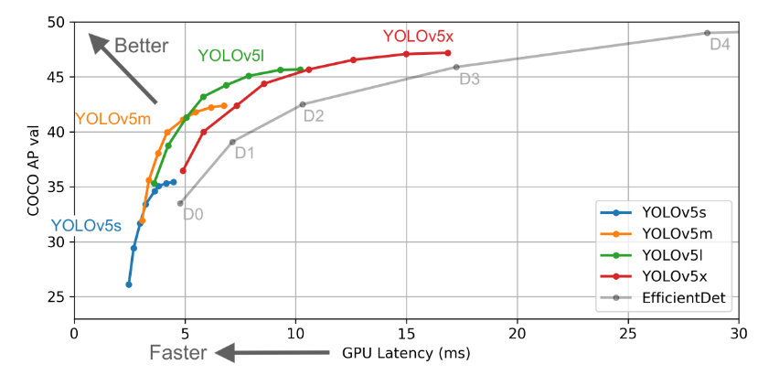

**Advantages of YOLOv5 and YOLOv5x:**

1. **Extremely Fast Inference:**  
   One of the key strengths of YOLOv5 is its ability to perform **real-time object detection**. Thanks to its single-stage architecture, YOLOv5 processes images quickly and outputs predictions in a fraction of a second, making it ideal for applications that require high frame rates, such as live video processing and autonomous systems.
2. **Lightweight and Suitable for Edge Deployment:**  
   YOLOv5 is highly optimized for **edge devices** such as smartphones, drones, and embedded systems. Due to its efficient architecture, YOLOv5 can run with relatively low computational resources, making it ideal for deployment on devices with limited processing power.
3. **High Accuracy:**  
   YOLOv5 and its extended version YOLOv5x achieve **high accuracy** in detecting objects in both simple and complex scenes. YOLOv5x, with its increased model parameters, excels in more challenging environments with dense object arrangements or overlapping objects.
4. **Flexibility for Different Use Cases:**  
   YOLOv5 and YOLOv5x can be used across a wide range of use cases, from security surveillance and traffic monitoring to retail and robotics. The model can be fine-tuned for specific tasks, and it supports multi-class detection, making it versatile for various applications.

**Disadvantages of YOLOv5 and YOLOv5x:**

1. **Slightly Less Accurate in Dense Object Scenes:**  
   While YOLOv5 and YOLOv5x are fast and accurate, they are not always as precise as other models like **Mask R-CNN** when detecting objects in **dense scenes** where objects overlap or have irregular shapes. In these cases, Mask R-CNN’s instance segmentation capabilities may outperform YOLO models in accurately segmenting objects.
2. **Requires Careful Hyperparameter Tuning:**  
   YOLOv5 models require careful tuning of **hyperparameters** such as learning rate, number of epochs, and batch size. Improper tuning can lead to suboptimal performance or overfitting, especially when working with large or highly varied datasets. Fine-tuning is essential to achieve the best balance between speed and accuracy.
3. **Inference Speed Trade-offs for YOLOv5x:**  
   While YOLOv5x provides superior accuracy, its larger model size results in slower inference speeds compared to YOLOv5. This can be a limiting factor when real-time performance is critical, and the larger model requires more computational resources, which may not be available on certain edge devices.

**Compatibility Requirements:**

* **Framework:**  
  YOLOv5 is implemented in **PyTorch**, which provides the necessary tools for training and deploying deep learning models. PyTorch’s flexibility and ease of use make it ideal for experimentation and fine-tuning of models like YOLOv5 and YOLOv5x.
* **Tools:**
  + **NVIDIA GPUs:** Training YOLOv5 models, especially for larger datasets, requires access to **NVIDIA GPUs** for faster computation. The GPUs accelerate both the training and inference processes.
  + **YOLOv5 Repository:** The official **YOLOv5 GitHub repository** provides pre-trained models, configuration files, and scripts to simplify the training and evaluation of the YOLOv5 model.

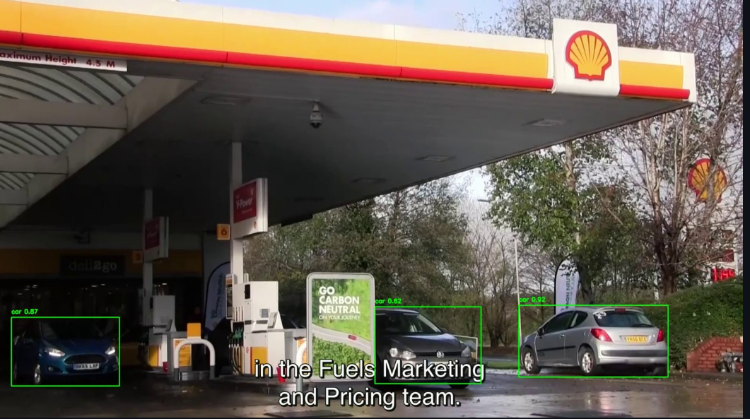

**Comparative Analysis**

| **Model** | **Advantages** | **Disadvantages** | **Best Use Case** |
| --- | --- | --- | --- |
| Faster R-CNN | High accuracy, robust detection | Slow inference | Complex images with fewer objects |
| Mask R-CNN | Detection + segmentation capabilities | Computationally intensive | Medical imaging, segmentation tasks |
| YOLOv5 | Real-time detection, lightweight | Slightly less accurate for dense scenes | Real-time applications |
| YOLOv5x | Higher accuracy for larger datasets | Increased computational requirements | Large-scale datasets |

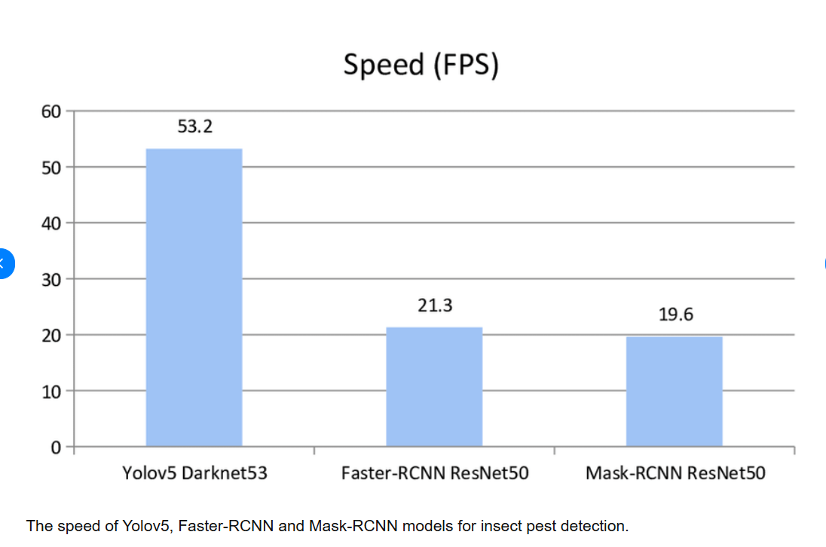

**Results and Conclusion**

After evaluating all models, YOLOv5 and YOLOv5x emerged as optimal choices for real-time object detection due to their speed and ease of deployment. Mask R-CNN excelled in applications requiring segmentation due to its ability to generate high-resolution masks. Faster R-CNN provided a balance between accuracy and robustness for object detection in complex scenes but lagged in real-time performance.

The project demonstrated that model selection is highly dependent on the use case. For example:

* Real-time detection tasks (e.g., surveillance) are best handled by YOLO models.
* High-precision segmentation tasks (e.g., medical imaging) benefit from Mask R-CNN.

These findings underscore the importance of aligning model capabilities with application-specific requirements. Future work could explore integrating transformer-based models or refining current architectures for edge deployment.

**Future Work**

**1**. **Enhancing Dataset Diversity**:

One of the primary avenues for future improvement lies in incorporating more diverse datasets. Currently, the object recognition system is limited by the range and diversity of the objects and environments within the training datasets. By expanding the dataset to include a broader range of object classes, environments, and conditions (e.g., varying lighting, occlusions, and backgrounds), the system will be able to generalize better across different real-world scenarios. Additionally, adding domain-specific datasets, such as those focusing on medical imaging or industrial applications, could enable the system to cater to more specialized use cases.  
  
**2**. **Optimizing Model Performance**:

To improve the system’s applicability in real-time and edge-device scenarios, further work could be done to optimize the performance of the models. Techniques such as model pruning and quantization can reduce the model size and computational complexity without sacrificing accuracy. Model pruning involves removing redundant or unnecessary neurons, whereas quantization reduces the precision of weights to lower bit depths, both of which can help speed up inference times and enable deployment on resource-constrained devices. Experimenting with these techniques will allow the system to be more efficient and suitable for use in mobile or embedded applications.  
  
**3**. **Exploring New Architectures**:

While the current object recognition system has demonstrated solid performance using models like Faster R-CNN, Mask R-CNN, and YOLO, there are newer architectures that could provide further enhancements. Transformer-based models, such as the DEtection TRansformer (DETR), have recently gained popularity for object detection tasks. Unlike traditional CNN-based models, DETR leverages transformers to model the global relationships between objects, which could potentially improve performance on complex detection tasks involving multiple objects or fine-grained object segmentation. Further exploration of such architectures could offer an opportunity to push the boundaries of detection accuracy and efficiency.  
  
**4. Integrating Multi-Modal Inputs:**

Another promising direction for future work is the integration of multi-modal inputs, where the object recognition system can process and learn from various data types such as images, video, depth information, and even sensor data. For example, combining camera data with LiDAR or radar inputs can provide additional spatial and depth information, which is particularly useful in challenging environments such as autonomous vehicles. Additionally, integrating natural language processing (NLP) to provide context for detected objects (e.g., recognizing object relationships and scene understanding) could enhance the system’s overall capability to perform more complex tasks.  
  
**5. Improving Robustness and Generalization**:

While the current system performs well in controlled conditions, real-world environments are often unpredictable. Addressing issues such as object occlusions, scale variations, and changes in viewpoint will be key to improving the system’s robustness. Exploring techniques like domain adaptation and few-shot learning could help the system generalize better to unseen objects and environmental conditions. Furthermore, continual learning methods could allow the system to adapt to new objects and scenarios as they emerge, thus ensuring that the system remains effective over time.

**References**

Redmon, J., Divvala, S., Girshick, R., & Farhadi, A. (2016). You Only Look Once: Unified, Real-Time Object Detection. CVPR.

He, K., Gkioxari, G., Dollár, P., & Girshick, R. (2017). Mask R-CNN. ICCV.

Fast R-CNN: https://arxiv.org/abs/1504.08083

Ultralytics YOLOv8 Documentation: https://github.com/ultralytics/yolov8